**Assignment 2 - Scenario 2**

**Introduction -**

This report will show a Test Plan for my network. It will Comprehensively test the network using the devised Test Plan and Provide scripts/files/ screenshots of the testing of the network by Making some improvement recommendations. It will also critically evaluate the design, planning, configuration and testing of the network.

Network Design model for Scenario 2 -

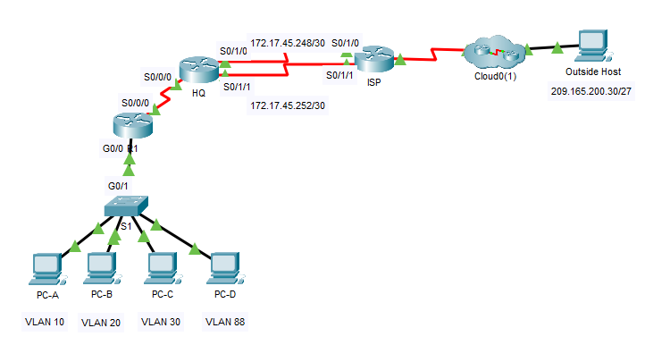

# **Requirements**

1) Configure inter-VLAN routing on **R1** based on the **Addressing Table**.

**1.1 - R1 Vlan addressing based on address table**

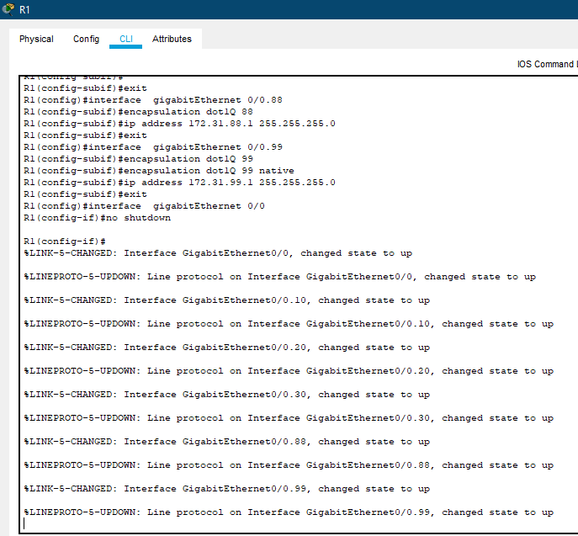

**PC-A Configurations -**

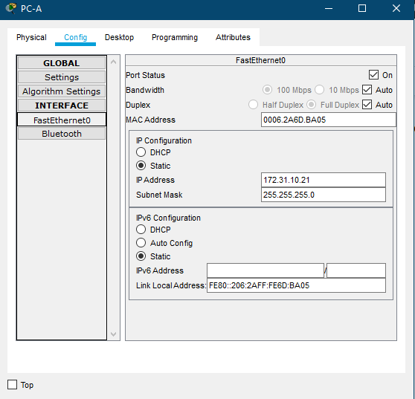

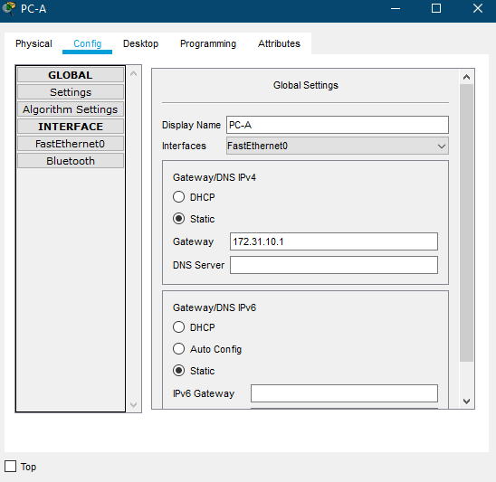

**PC-B Configurations -**

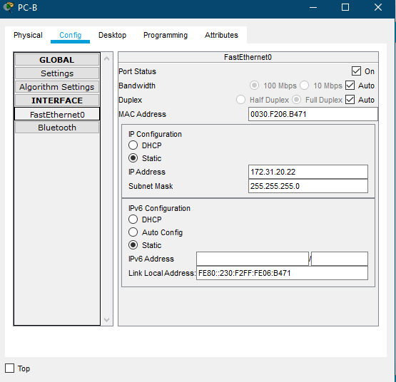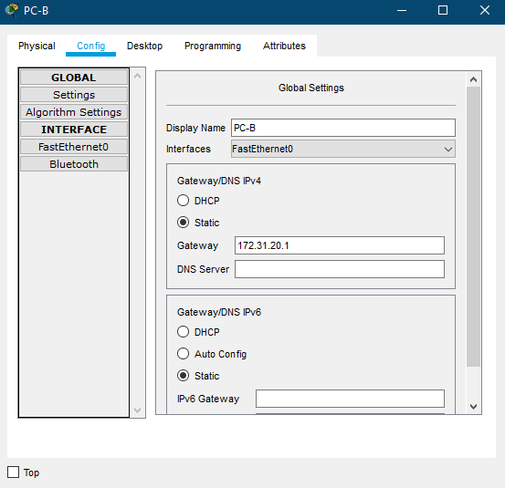

**PC-C Configurations -**

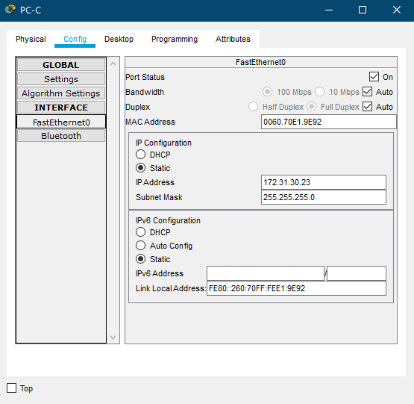

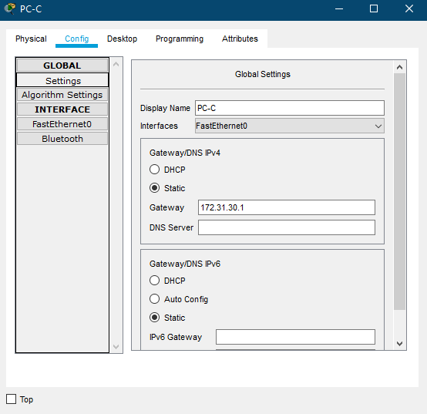

**PC-D Configurations -**

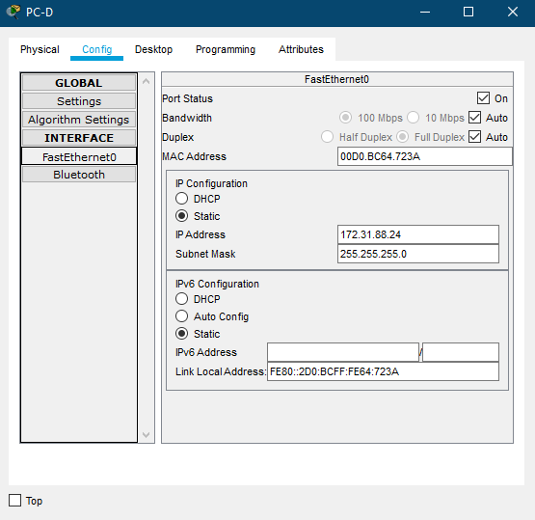

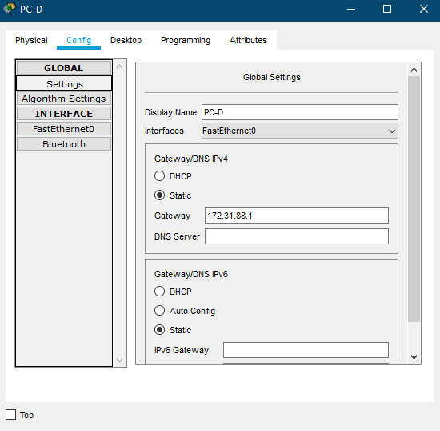

**1.2 - R1 running config**

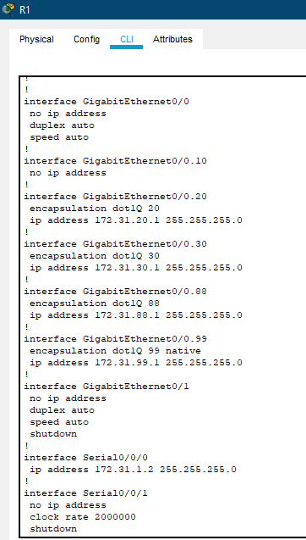

**2) Configure trunking on S1.**

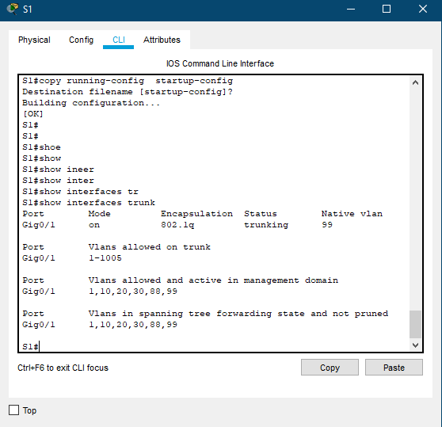

3) Configure four directly attached static routes on **HQ** to each VLANs 10, 20, 30 and 88.

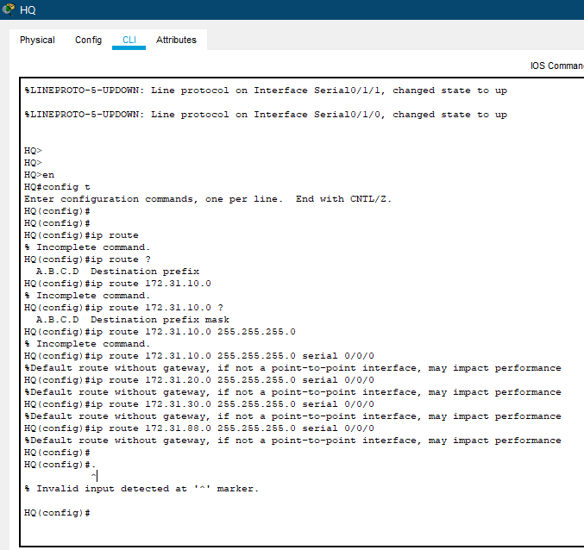

4) Configure directly attached static routes on **HQ** to reach **Outside Host**.

* Configure the primary path through the Serial 0/1/0 interface.
* Configure the backup route through the Serial 0/1/1 interface.

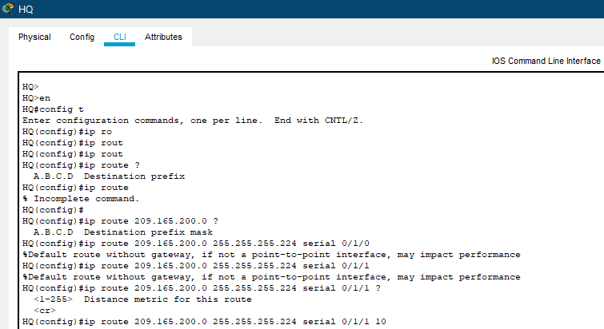

5) Configure a directly attached default route on **R1**.

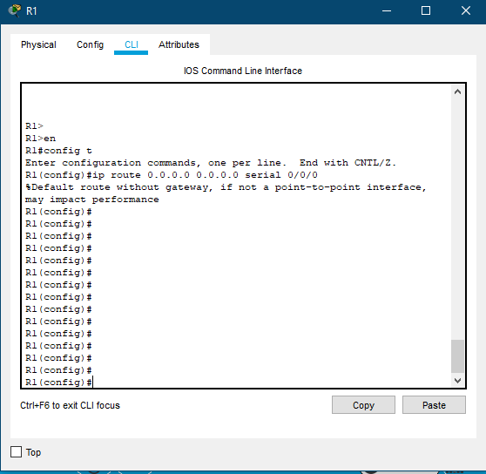

6) Enter the command to view the port status and disable all unused ports on **S1**.

**R1 ip subnet interface brief**

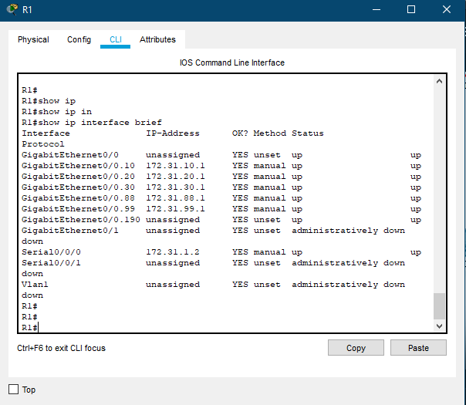

7) Verify connectivity by making sure all the PCs can ping **Outside Host**.

Pinging from **PC-A** to **Outside Host -**

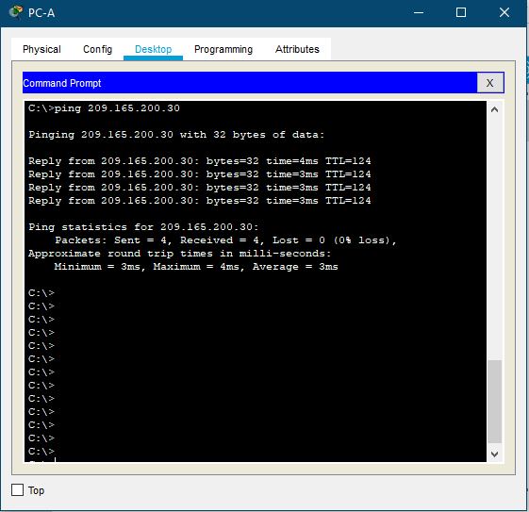

Pinging from **PC-B** to **Outside Host -**

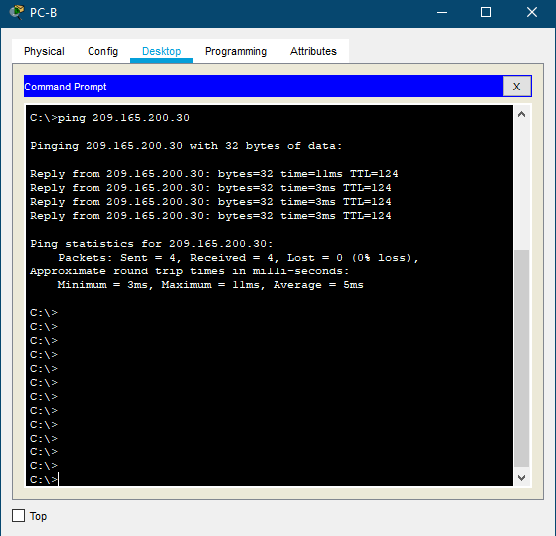

Pinging from **PC-C** to **Outside Host -**

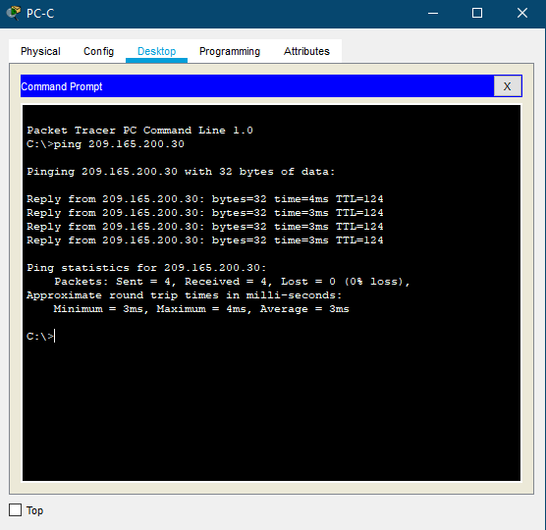

Pinging from **PC-D** to **Outside Host -**

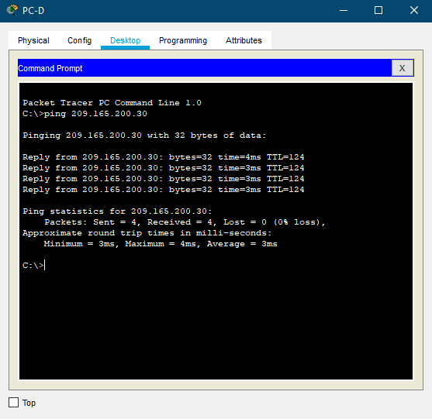

**Comprehensively test the network, provide screenshots and report any problems in the troubleshooting table below.**

**Troubleshooting Documentation**

|  |  |
| --- | --- |
| **Problem** | **Solution** |
| VLan no. not showing up in the ‘show vlan brief’ | Made a mistake in naming the vlan and disabling unused ports for the vlan and re-configuring vlans to specified PC. |
| PC not pinging to the router | Resetting the router and double checking the configurations. |
| PCs not pinging to the ‘Outside Host PC’ | One of the routers was not set up properly. |
| PCs not pinging to other PCs | The Subnet mass was set up incorrectly |

**Improvements and recommendations that could be made to the above network**

**Implementing an extra switch -**

Based on my work and looking at the scenarios I would suggest adding another switch so that the load on the network gets distributed evenly across the network. It would benifit the network design by improving the flow of packets flowing across the network and making for a better design choice overall. Even if one switch fails

**Implementing an extra Router -**

As the scenario suggests, there are 3 routers already implemented in the design, but in order to further improve this design I would recommend implementing a separate router which could act as a backup if one of the routers is offline. By adding a backup router for all the 3 routers could benefit the network if there was a failure in any of the 3 routers this design would improve the quality of the network design.

**Expanding the Network Design -**

As it would seem that the scenario adopted a network design which restricts the network with a single flow of packets across the whole network. As there is only one PC at one end of the network which is the **Outside Host** PC which receives all the traffic from all the **4 PCs** on the other end, as the packets flow through switches and routers it puts a lot of load on the network server. My recommendation would be to branch out the network so that it is more flexible for packets to travel across the network and would be a more efficient and effective design for the network. As the network design in the scanerio seems a bit too congested in its design but works in delivering the pockets to its destination device.

**Backup Cloud for the Network -**

There is only one cloud server which the server manages in any circumstance if the cloud would be out of service or offline for a moment it would crash the whole server. In that case implementing a backup cloud server to the network would not only avoid any risk of bringing the server down but also provide more room for data to flow from without interrupting the flow of traffic across the network.

**Critical evaluation of the above network design, my planning, configuration and testing and how could it be better implemented next time.**



According to my experience and what I have learnt while designing the network I have an idea of how the network works and what could be done better. As mentioned in the previous section I have mentioned the Improvements and recommendations that could be made to the above network. I will list out how the planning, configuration of the network and testing could it be better implemented next time.

**1. Determine that the network is at fault.**

Is the network very slow, or are just running slow computers? Without understanding the condition can not recommend a treatment, so it's best not to leap to conclusions. Before springing for an infrastructure upgrade make sure the slow response time is more than just a localised problem.

**2. Offer guests a different network.**

Often network slowdowns are the product of guest behaviour. While it is unlikely that the source of the troubles is a single guest streaming a Tube video in the lobby, if frequently host a large number of guests who need internet access, could have problems. Rather than inadvertently risk them slowing down the operations, offer them a login to a network of guests.

**3. Use VLANs to segment low-priority traffic.**

VLANs (Virtual Local Area Networks) are an ideal way to segment the network resources, such that the highest priority is given to the most important traffic. Essentially, a VLAN provides the benefits of a different network, without having to rewire the entire office. can group the VLANs based on the use and function of the computer, even if they are in separate office areas.

**4. Check for viruses or system defects.**

Viruses, malware are known to slow down networks and interfere with workflows. If suspect that the network slowdown may result from malicious network activity, should immediately have an emergency IT specialist conduct a check of the situation. Slowdowns can also be the result of growing old and defective, different network components. Replacing those broken components is often relatively painless, rather than upgrading the entire network.

**5. Monitor for bottlenecks.**

Network monitoring is critical to the diagnosis of any range of potential traffic jams or bottlenecks in the network. Device backups for example usually consume a significant amount of resources. Regardless of that, when workers are out of town, most networks run their backups at night. But the scheduling on those backups is sometimes off, or a backup takes longer than expected and starts running into the day of work. Remote monitoring and maintenance (RMM) services can detect these congestion sources, allowing IT staff to design more efficient workarounds.

**6. Update software and firmware.**

Engineering developments and the applications running on them don't always keep up with one another. may have new programmes running on old computers, or old programmes running on new ones — anyway, they 're unlikely to fit together well. If we are tied to an old software system simply because that is the way it has always been done, it may be high time to set it aside in favour of something more compatible with current technology. Otherwise, the fondness for yore software could strand the stone age business.

**7. Upgrade the network.**

It's possible I just need to upgrade the network. While should certainly do the due diligence in seeking other remedies, the truth is that networks are wearing out, and they sometimes need replacement. Luckily as we said earlier, Internet broadband has never been more accessible. If 're still running on old cabled Internet , a new wired connexion may smooth over the biggest delays.

**8. Networks don’t stay perfectly optimized forever.**

No matter how well the network is designed, nothing stays the same. the applications will evolve, the company will update software, consumer preferences will move, and the network will fall behind powerful, high-performance networks that require the network's oversight and maintenance.

**Conclusion -**

In conclusion, this report shows a Test Plan for my network. It also Comprehensively tests the network using the devised Test Plan and Provides scripts/files/ screenshots of the testing of the network by Making some improvement recommendations. It also critically evaluates the design, planning, configuration and testing of the network.

**Resources -**

Brightline Technologies. 2020. *8 Tips To Improve Network Performance In the Office - Managed IT*. [online] Available at: <https://brightlineit.com/8-tips-to-improve-network-performance-in-the-office/> [Accessed 25 May 2020].

Default. 2020. *Network Troubleshooting | How To Fix A Network Connection | Computer Network | Comptia*. [online] Available at: <https://www.comptia.org/content/guides/a-guide-to-network-troubleshooting> [Accessed 25 May 2020].

Chan, A., 2020. *Setup VLAN Subnets For Home Network - Netosec*. [online] NetOSec. Available at: <https://netosec.com/home-network-vlans/> [Accessed 25 May 2020].

www.connectioncafe.com. 2020. *Connection Cafe*. [online] Available at: <https://www.connectioncafe.com/7-easy-ways-to-improve-network-performance/> [Accessed 25 May 2020].